------------------------------- Collections in Java By Durgesh ------------------------

Collection: A group of object and then represent as single unit.

Framework: Its an build with classes and interface. We we have use it provide redy-made architecture.

Collection Framework: It is an java API which provide archetecture to store and maniplute group of object.

Collection Hierarchy:
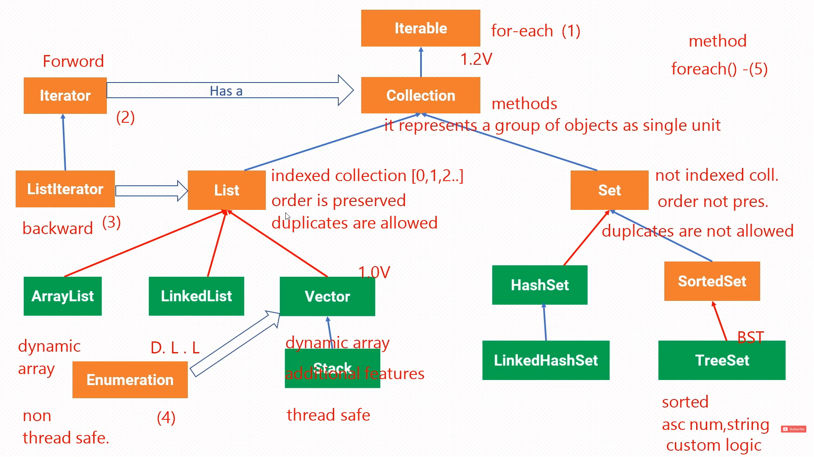

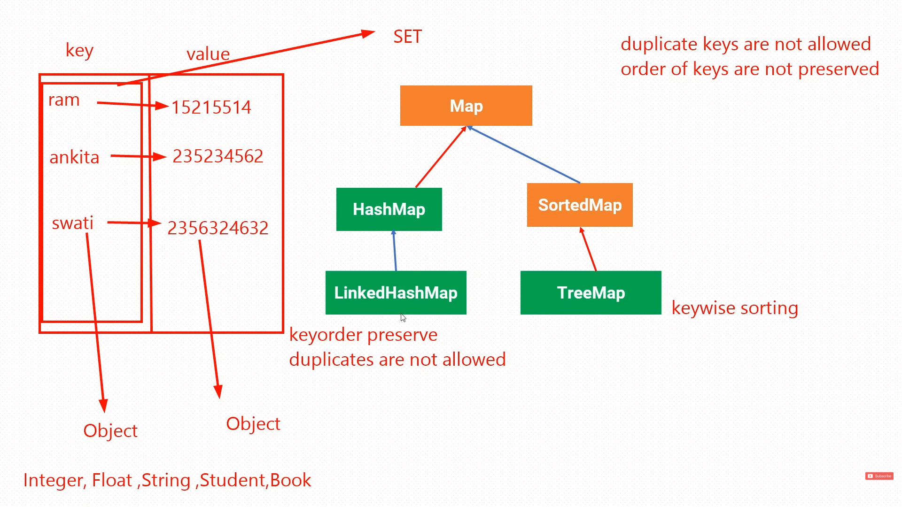

In Java's Collections Framework, the distinction you are referring to is commonly understood as thread-safe versus non-thread-safe collections. This relates to how they handle concurrent access from multiple threads.
Thread-Safe Collections (e.g., Vector)
Thread-safe collections are designed to be safely accessed and modified by multiple threads simultaneously without causing data corruption. They achieve this through internal synchronization mechanisms.
Example of Vector (Thread-Safe List):
Java
import java.util.Vector;
public class ThreadSafeExample {
public static void main(String[] args) {
Vector<String> names = new Vector<>(); // Creating a Vector of Strings
// Adding elements
names.add("Alice");
names.add("Bob");
names.add("Charlie");
// Accessing elements
System.out.println("Elements in Vector: " + names);
System.out.println("First element: " + names.get(0));
// Removing elements
names.remove("Bob");
System.out.println("Elements after removal: " + names);
// Iterating (note: iterators on Vector are fail-fast but not thread-safe for concurrent modification)
for (String name : names) {
System.out.println("Name: " + name);
}
}
}

Non-Thread-Safe Collections (e.g., ArrayList, LinkedList)
Non-thread-safe collections do not provide internal synchronization. While generally faster in single-threaded environments, they require external synchronization mechanisms (like synchronized blocks or Lock objects) if used in a multi-threaded context to prevent data inconsistencies.
Example of ArrayList (Non-Thread-Safe List):
Java
import java.util.ArrayList;
import java.util.List;
public class NonThreadSafeExample {
public static void main(String[] args) {
List<Integer> numbers = new ArrayList<>(); // Creating an ArrayList of Integers
// Adding elements
numbers.add(10);
numbers.add(20);
numbers.add(30);
// Accessing elements
System.out.println("Elements in ArrayList: " + numbers);
System.out.println("Element at index 1: " + numbers.get(1));
// Modifying elements
numbers.set(0, 5);
System.out.println("Elements after modification: " + numbers);
// Iterating
for (Integer num : numbers) {
System.out.println("Number: " + num);
}
}
}
Key Difference:
The primary distinction is Vector's inherent synchronization, making it suitable for multi-threaded environments without explicit external synchronization, but at a potential performance cost compared to ArrayList in single-threaded scenarios. Modern Java often prefers ArrayList and explicit synchronization or concurrent collection alternatives (like CopyOnWriteArrayList) when thread safety is required.

Yes, it is possible to create an ArrayList containing all elements from a TreeSet in Java. There are several ways to achieve this: Using the ArrayList constructor.
The ArrayList class has a constructor that takes a Collection as an argument. Since TreeSet implements the Set interface, which extends Collection, you can directly pass a TreeSet object to the ArrayList constructor.
Java
import java.util.ArrayList;
import java.util.TreeSet;
public class TreeSetToArrayList {
public static void main(String[] args) {
TreeSet<String> treeSet = new TreeSet<>();
treeSet.add("Apple");
treeSet.add("Banana");
treeSet.add("Orange");
ArrayList<String> arrayList = new ArrayList<>(treeSet);
System.out.println("TreeSet: " + treeSet);
System.out.println("ArrayList: " + arrayList);
}
}
Using the addAll() method of ArrayList.
You can create an empty ArrayList and then use its addAll() method to add all elements from the TreeSet.
Java
import java.util.ArrayList;
import java.util.TreeSet;
public class TreeSetToArrayListAddAll {
public static void main(String[] args) {
TreeSet<Integer> treeSet = new TreeSet<>();
treeSet.add(10);
treeSet.add(5);
treeSet.add(20);
ArrayList<Integer> arrayList = new ArrayList<>();
arrayList.addAll(treeSet);
System.out.println("TreeSet: " + treeSet);
System.out.println("ArrayList: " + arrayList);
}
}
Both methods will result in an ArrayList containing the elements of the TreeSet. Note that while TreeSet maintains elements in a sorted order, the ArrayList will simply store them in the order they were retrieved from the TreeSet (which will be the sorted order). The ArrayList itself does not inherently maintain sorted order, although the initial state reflects the TreeSet's order.

